First of all I have updated the source list by using following command in compiler:

sudo apt-get update

following is screenshot:

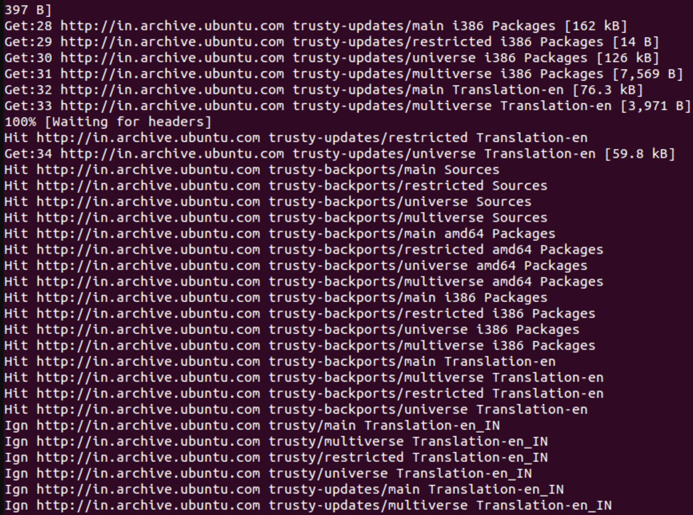

Then we add hadoop user account for running hadoop by using following command:

sudo addgroup hadoop_group

sudo adduser --ingroup hadoop_group user

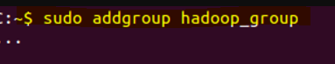



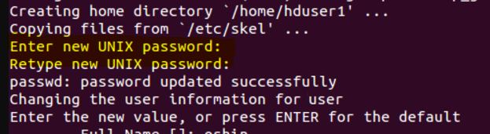

Add user to the sudo group

sudo adduser hduser1 sudo

We have to generate an SSH key for the user user.

su – user

ssh-keygen -t rsa -P ""

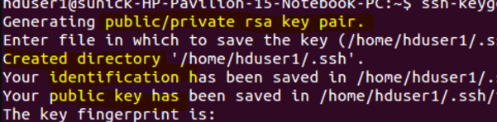

I enabled SSH access to my local machine with this newly created key which is done by the following command.

cat $HOME/.ssh/id_rsa.pub >> $HOME/.ssh/authorized_keys

I added the following entries to .bashrc file

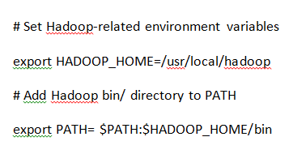

I ran the command to Namenode, Datanode, Jobtracker and a Tasktracker on the machineby following statement



This gives us following results:

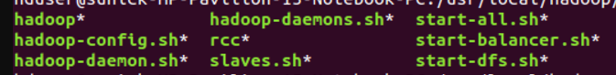



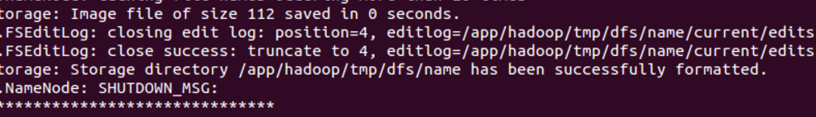

In order to check if hadoop is working properly we do following:

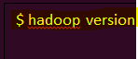

Then it gives us specifications of hadoop:

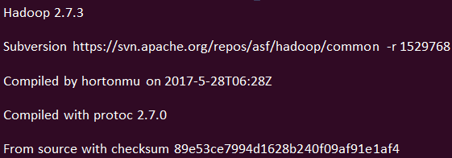

Hadoop has been installed and configured completely.

I have taken help from tutorials for installing and configuring from following website:

<http://doctuts.readthedocs.io/en/latest/hadoop.html>

**Final result of lab:**

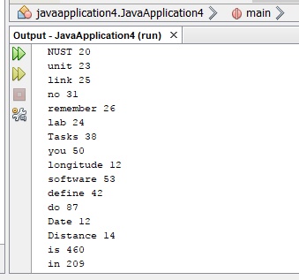

I created two classes called mapper function and reducer function.

/*

* To change this license header, choose License Headers in Project Properties.

* To change this template file, choose Tools | Templates

* and open the template in the editor.

*/

H =<dfs.http.address,50070>;

Reduce=Dfs.datanode.http.address<50075>;

Mapper m= mapred.job.tracker.http.address<50030>;

Main-Class: reduce_function

import java.io.BufferedReader;

import org.apache.hadoop.io.LongWritable;

hadoop.log.dir.

/dfsnodelist.jsp?whatNodes=(DEAD|LIVE)

/listPaths/user/philip?filter=file.*

/data

/filechecksum

/browseBlock.jsp.

/browseDirectory.jsp.

/streamFile

/getFileChecksum

/browseDirectory.tail.

import java.io.FileReader;

/metrics?format=json

import java.io.IOException;

package beginnersbook.com;

import java.util.HashMap;

import java.util.Map;

import java.util.Iterator;import java.io.IOException;

import org.apache.hadoop.mapreduce.Reducer;

import java.util.Set;

package mapper_function;

package reduce_function;

import java.io.BufferedReader;

import java.io.FileReader;

import java.io.IOException;

import java.awt.Frame;

import java.awt.Label;

import java.awt.event.WindowAdapter;

import java.awt.event.WindowEvent;

export JAVA HOME=/usr/java/default

export PATH=${JAVA_HOME}/bin:${PATH}

export HADOOP_CLASSPATH=${JAVA_HOME}/lib/tools/jar

/**

*

* @author test1

*/

public class mapper_function {

/**

* @param args the command line arguments

*/public class master{}

Public Class slave{}

class mapperfunction{

public static void main(String[] args) {FILE *lab1,*lab2, *lab3,*lab4, *lab5, *lab6, *lab7,

*lab8, *lab9, *lab10, *lab11, *lab12;

List<*FILE> records = new ArrayList<*FILE>(); List<String>L=new List<String>;

Records(1)=fopen(”lab1.txt”);

Records(2)= fopen(”lab2.txt”);

Records(3)= fopen(”lab3.txt”);

Records(4)= fopen(”lab4.txt”);

Records(5)= fopen(”lab5.txt”);

Records(6)= fopen(”lab6.txt”);

Records(7)= fopen(”lab7.txt”);

Records(8)= fopen(”lab8.txt”);

Records(9)= fopen(”lab9.txt”);

Records(10)= fopen(”lab10.txt”);

Records(11)= fopen(”lab11.txt”);

Records(12)= fopen(”lab12.txt”);

string str[999]; FILE * file;

file = fopen( "test.txt" , "w");

For(int i=1;i<=12;i++){file= Records(i);

if (file) {

map(file);

}

}

void map(FILE* textfile){

string[] words=file;

for(string i=textfile.begin();i!="\0";i++)

{ string.delimiter(" ");

HashMap<String, integer > h = new HashMap< String, integer >;

h .put<key,1 >;

}

Reduce_function r=new reduce_function();r.reduce(h);

}

}

public class reduce_function{

void reduce(hashmap<string,int> filewords){int p=0;

for(int i=filewords.value.begin();i!="\0";i++){

for(int j=filewords.value.begin-i;j!="\0";j++){

if(i.key()==j.key()&&i!=j)

{

p=i.value()+j.value();

}

}

jar cfm Manifest.txt reduce_function.jar reduce_function.class;

}

}}

Void print(){HashMap<String,integer>h=new HashMap<String,integer>;

h=hash;

For(i=hashmap.begin();i<=h.end();i++)

System.out.println(h.key);

System.out.println(h.value);

System.out.println(“\n”);

}

}